Business Section

**What the business is**

My boss is from celebrity industry. Celebrity culture can be viewed as synonymous with celebrity industry, where celebrities are treated as products to be sold. Celebrity culture is a high-volume perpetuation of celebrities' personal lives on a global scale. It is inherently tied to consumer interests where celebrities transform their fame to become product brands.

Nowadays celebrities have great commercial influence. Social media like Instagram, Snapchat, or Twitter may have much more traffic than TV shows or TV ads. If a person had over one million followers on Instagram, he or she could be a celebrity no matter what he or she do for living.

**What problem the business has**

Hence, companies would have problem on hiring which celebrity to endorse their product that worth the money paid to the celebrity. My boss wants a database for a celebrity website, which has a complete set of information for each celebrity. The reason why the database is storing news, figures of a celebrity is that the business wants the real traffic from the market. The business is using that information as a bait to attract people to see celebrity they are interested in. Combining the amount of traffic and the last commercial advertisement paid amount, companies can choose to hire a celebrity that’s suitable for them. What’s more, a company can choose a celebrity to endorse its product based on the amount of read on his or her news and the product related word in that news. I’ll give an example in the report 5 in the reports section.

**Specifications the business needs**

1. The database needs to include the information from basic information like bio to advanced info like partners, rumors, figures and so on.
2. People can search the whole file, which includes the works, news, and etc., of a certain celebrity just by typing in the name.
3. The database needs to store the number of visits for each celebrity, the last commercial advertisement paid amount, and the agent’s info.

**Reports**

Group by type

Report 1

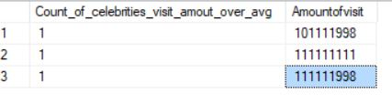

It shows the count of celebrities whose number of visits is over the average amount of visit of all celebrities in the database.

Report 2

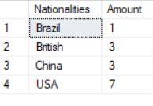

It shows the count of celebrities from each country.

Join type

Report 3

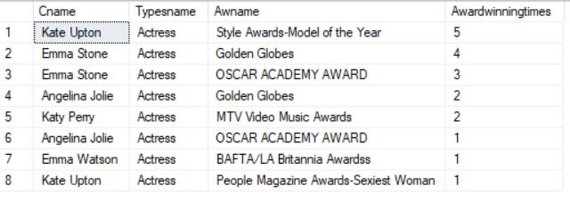

It shows the most award-winning times actress and the name of the award by joining the celebrity’s info and awards table, sorted by the award-winning times.

Report 4

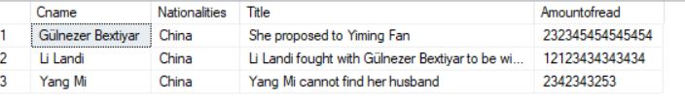

It shows the hottest celebrity from China right now by joining the celebrity’s info and news table. It only shows those celebrities whose news traffic are over the average, sorted by the amount of read of the news.

**Regular**

Report 5



It shows celebrities and their latest news which contains the key word ‘coffee’. It also shows the news title, amount of read of that news, and the last commercial paid of the celebrity. It’s sorted by amount of read of the news. A coffee brand may want to use this information to choose a celebrity to endorse its product.

Report 6

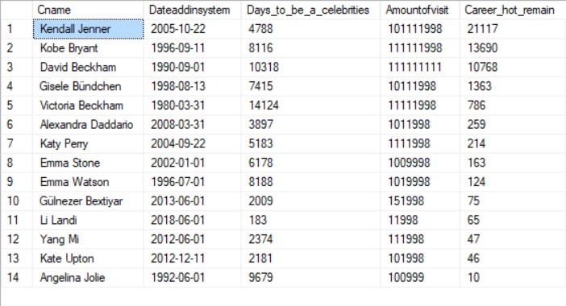

It shows the amount of traffic amortized in each day of his or her celebrity career based on the assumption that the date of a celebrity being added in the system is the date he or she officially become a celebrity. We know that celebrities may have some high light times and down times. So, the index ‘Career hot remain’ here can give companies an idea that if the index is high, either the celebrity is having his or her career high light and hasn’t become a celebrity for too long or the celebrity’s career is always climbing.

**INTENTIONALLY LEFT BLANK**

**Sub queries**

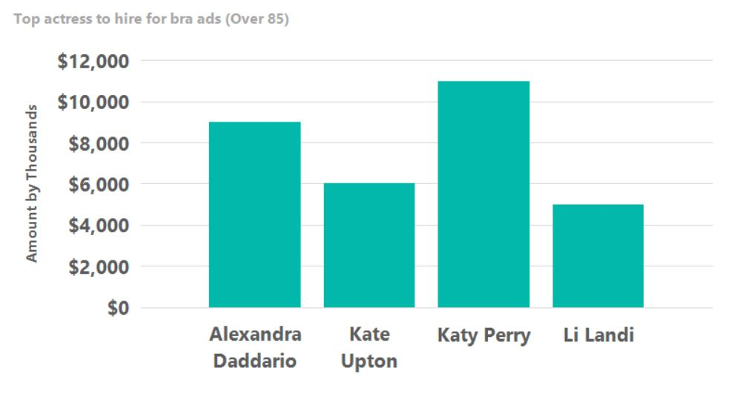Report 7

It shows the top actress to hire for a bra’s advertisement by showing whose bust is over 85 (cm) and their last commercial paid amount.

Report 8

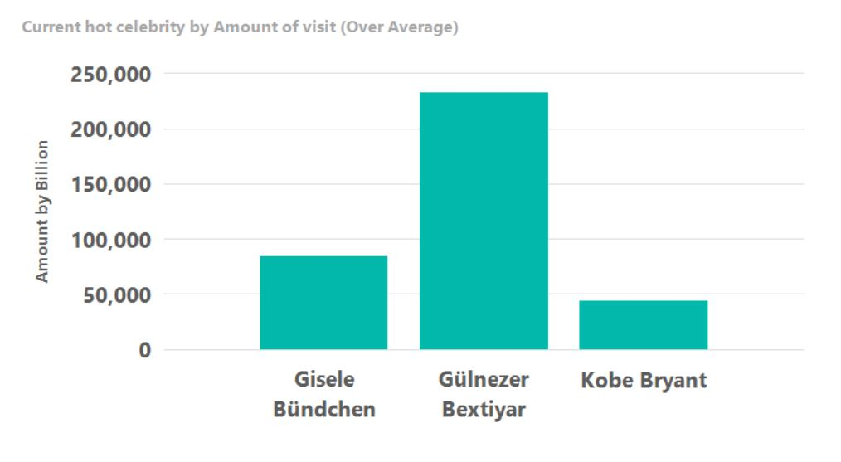

It shows the top current hot celebrities, filtered by the average news traffic amount. The X axis shows the name and the Y axis shows the amount of read of his or her latest news.

I believe all the reports can give companies some clues or ideas on choosing which celebrity to advertise their products.